Degenerate Conic

Definition
# Source: AI Source: Provided by: [Data Path: Persons Table -> ID Column: 1, Name_En Column: Motasem Essam] -> From: [ChatGPT] on [7/25/2026]
A Degenerate Conic is a conic defined by a second-degree equation that represents a simpler geometric object, such as a point, a straight line, a pair of intersecting lines, or a pair of parallel lines, rather than a nondegenerate ellipse, parabola, or hyperbola.
Degenerate conics arise when the coefficients of a conic equation satisfy special conditions that cause its usual shape to collapse.

Simple Definition
# Source: AI Source: Provided by: [Data Path: Persons Table -> ID Column: 1, Name_En Column: Motasem Essam] -> From: [ChatGPT] on [7/25/2026]
A degenerate conic is a conic whose equation represents a point, one or more straight lines, or no real points, instead of an ordinary conic curve.

Main Classification
# Source: AI Source: Provided by: [Data Path: Persons Table -> ID Column: 1, Name_En Column: Motasem Essam] -> From: [ChatGPT] on [7/25/2026]
The following is the practical classification of real degenerate conics in the Euclidean plane.
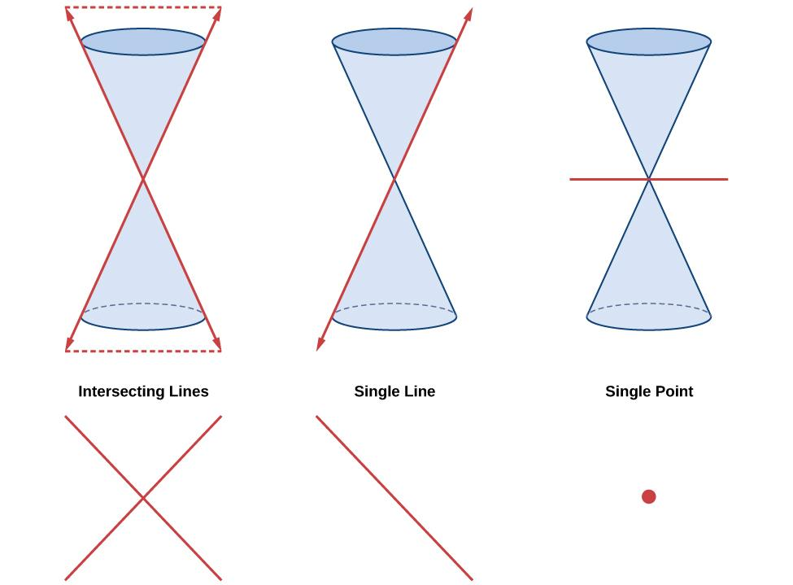

Add to Favorites

1. Pair of Intersecting Lines
# Source: AI Source: Provided by: [Data Path: Persons Table -> ID Column: 1, Name_En Column: Motasem Essam] -> From: [ChatGPT] on [7/25/2026]
A degenerate conic consisting of two distinct straight lines that intersect at one point.
Example:
$$x^{2}-y^{2}=0$$
Factoring gives
$$\left(x-y\right)\left(x+y\right)=0$$
Therefore, the conic consists of the lines $y=x$and $y=-x$, intersecting at the origin.
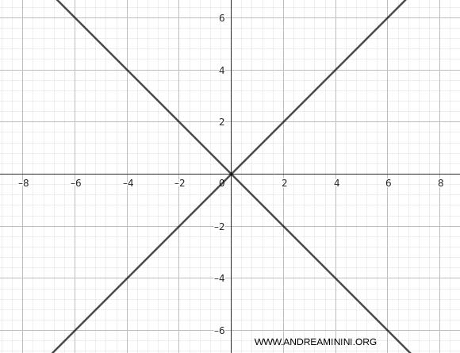
Add to Favorites

2. Pair of Parallel Lines
# Source: AI Source: Provided by: [Data Path: Persons Table -> ID Column: 1, Name_En Column: Motasem Essam] -> From: [ChatGPT] on [7/25/2026]
A degenerate conic consisting of two distinct parallel straight lines.
Example:
$$x^{2}-4=0$$
Factoring gives
$$\left(x-2\right)\left(x+2\right)=0$$
Therefore, the conic consists of the parallel lines $x=2$and $x=-2$.
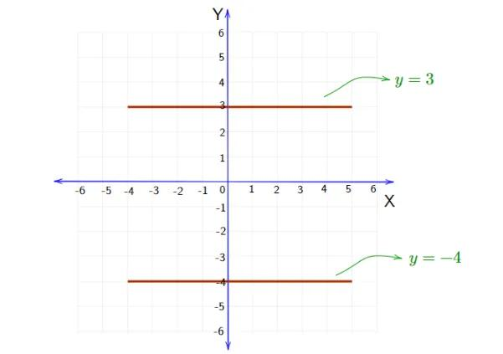
Add to Favorites

3. Pair of Coincident Lines
# Source: AI Source: Provided by: [Data Path: Persons Table -> ID Column: 1, Name_En Column: Motasem Essam] -> From: [ChatGPT] on [7/25/2026]
Two lines that overlap completely, appearing as a single line.
Example:
$$x^{2}-2xy+y^{2}=0$$
Factoring gives
$${\left(x-y\right)}^{2}=0$$
The resulting line is $y=x$, counted twice algebraically.
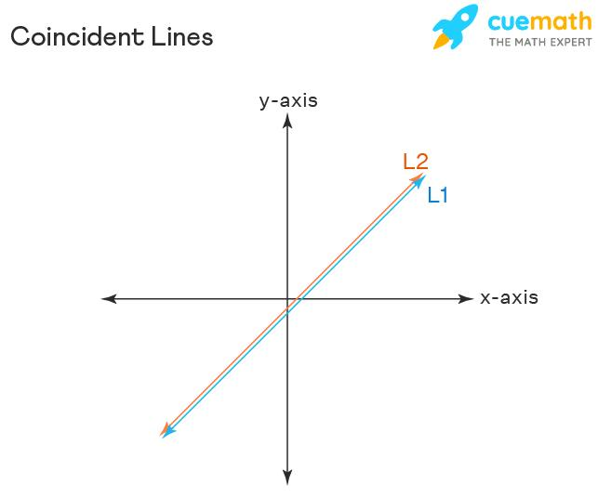
Add to Favorites

4. A Single Point
# Source: AI Source: Provided by: [Data Path: Persons Table -> ID Column: 1, Name_En Column: Motasem Essam] -> From: [ChatGPT] on [7/25/2026]
A degenerate conic whose real geometric locus consists of exactly one point.
Example:
$$x^{2}+y^{2}=0$$
Since both squares must be zero, the only real solution is
$$\left(x , y\right)=\left(0 , 0\right)$$
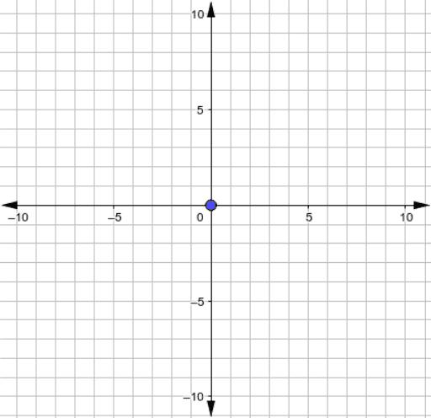

5. Empty Real Locus
# Source: AI Source: Provided by: [Data Path: Persons Table -> ID Column: 1, Name_En Column: Motasem Essam] -> From: [ChatGPT] on [7/25/2026]
Some real-coefficient conic equations have no real points.
Example:
$$x^{2}+y^{2}+1=0$$
Because $x^{2}+y^{2}≥0$, the left side is always at least $1$. Therefore, no real point satisfies the equation.
This is often included among degenerate conics in the real projective or algebraic classification, although some elementary treatments reserve the term for nonempty loci.
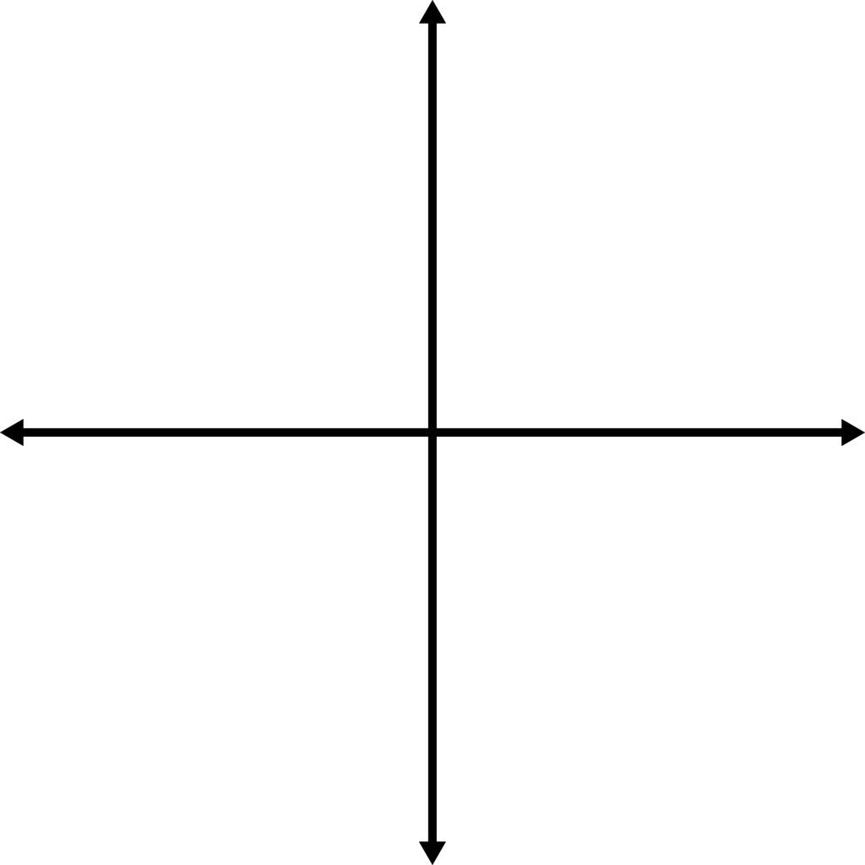

General Equation of a Conic
# Source: AI Source: Provided by: [Data Path: Persons Table -> ID Column: 1, Name_En Column: Motasem Essam] -> From: [ChatGPT] on [7/25/2026]
A general second-degree equation in two variables is
$$Ax^{2}+Bxy+Cy^{2}+Dx+Ey+F=0$$
where the coefficients are real numbers and at least one of $A,B,C$is nonzero for a genuine quadratic equation.
A useful test for a conic's type begins with the discriminant
$$Δ=B^{2}-4AC$$
For a nondegenerate real conic:
- $Δ<0$: ellipse type, including a circle.
- $Δ=0$: parabola type.
- $Δ>0$: hyperbola type.
However, these conditions alone do not determine whether the conic is degenerate. The remaining coefficients must also be considered.
Determinant test
The conic is degenerate when the following determinant is zero:
$$\boxed{∣\begin{matrix}A & B/2 & D/2 \\ B/2 & C & E/2 \\ D/2 & E/2 & F\end{matrix}∣=0}$$
This is the standard matrix criterion for a projective conic to be degenerate.

Degenerate vs. Nondegenerate Conic
# Source: AI Source: Provided by: [Data Path: Persons Table -> ID Column: 1, Name_En Column: Motasem Essam] -> From: [ChatGPT] on [7/25/2026]
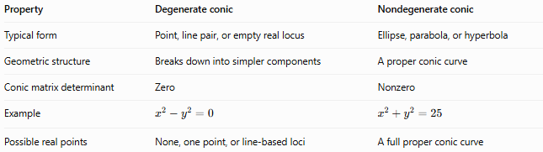
Property | Degenerate conic | Nondegenerate conic
Typical form | Point, line pair, or empty real locus | Ellipse, parabola, or hyperbola
Geometric structure | Breaks down into simpler components | A proper conic curve
Conic matrix determinant | Zero | Nonzero
Example | $$x^{2}-y^{2}=0$$ | $$x^{2}+y^{2}=25$$
Possible real points | None, one point, or line-based loci | A full proper conic curve

How Degenerate Conics Arise
# Source: AI Source: Provided by: [Data Path: Persons Table -> ID Column: 1, Name_En Column: Motasem Essam] -> From: [ChatGPT] on [7/25/2026]
Degenerate conics can arise from:
- Special coefficient relationships — for example, when the conic matrix determinant becomes zero.
- Limiting geometric configurations — certain limiting cases of conics can collapse to simpler objects.
- Intersecting planes with a cone — in projective geometry, a plane passing through the vertex of a cone can produce a pair of lines or a single point, depending on the configuration.

Classification Summary
# Source: AI Source: Provided by: [Data Path: Persons Table -> ID Column: 1, Name_En Column: Motasem Essam] -> From: [ChatGPT] on [7/25/2026]
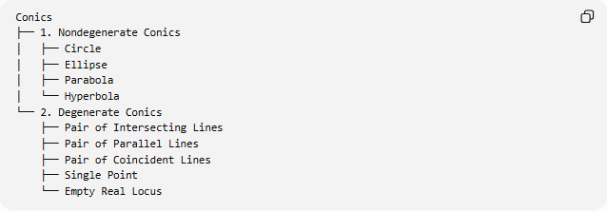
Conics
├── 1. Nondegenerate Conics
│ ├── Circle
│ ├── Ellipse
│ ├── Parabola
│ └── Hyperbola
└── 2. Degenerate Conics
├── Pair of Intersecting Lines
├── Pair of Parallel Lines
├── Pair of Coincident Lines
├── Single Point
└── Empty Real Locus
Note: This is a practical classification over the real numbers. In projective geometry, classifications may treat points at infinity and line pairs differently.

Key Points
# Source: AI Source: Provided by: [Data Path: Persons Table -> ID Column: 1, Name_En Column: Motasem Essam] -> From: [ChatGPT] on [7/25/2026]
- A degenerate conic is a special or collapsed form of a conic.
- It may represent two lines, one repeated line, a single point, or no real points.
- The equation $x^{2}-y^{2}=0$represents two intersecting lines.
- The discriminant $B^{2}-4AC$alone does not establish degeneracy.
- The conic matrix determinant provides a standard algebraic test.

Conclusion
# Source: AI Source: Provided by: [Data Path: Persons Table -> ID Column: 1, Name_En Column: Motasem Essam] -> From: [ChatGPT] on [7/25/2026]
A Degenerate Conic is a conic equation that fails to represent a nondegenerate conic curve. Its real geometric form may collapse to a point or straight line(s), or it may have no real points. Degenerate conics are studied mainly in Analytic Geometry, Conic Sections, and Projective Geometry.

